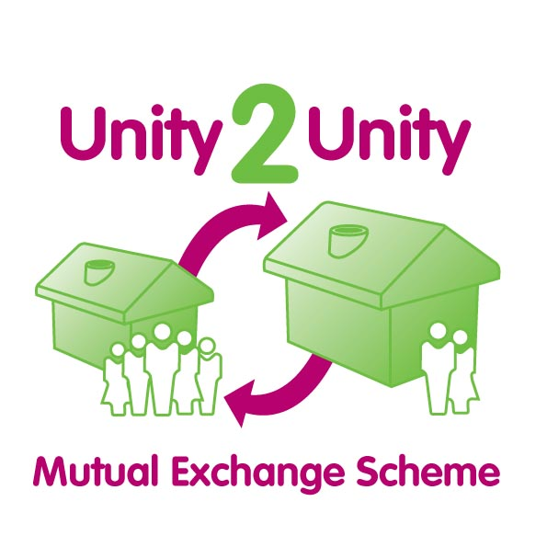

Type in the spaces and email to uha@unityha.co.uk or print the document, write in the spaces and post to: Unity Housing Association, 113-117 Chapeltown Road, Leeds, LS7 3HY.
By submitting this form, you give Unity the right to discuss your property details with other tenants.
About where you live:
Name:
Address:
Daytime: Mobile:
Type of property:
About where you’d like to live:
What type of property are you looking for?
What area would you like to live in?
How many bedrooms do you need? (see below)
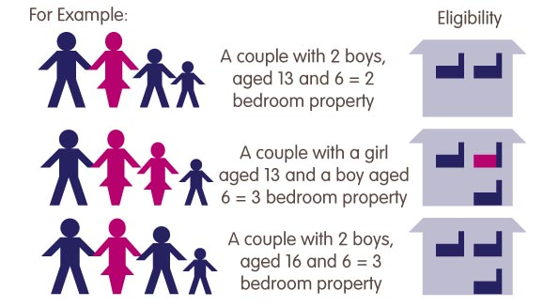
How many bedrooms do I need?
Under the new rules, you will be allowed one bedroom for each person or couple living as part of the household, with the following exceptions:
Children under 16 of the same gender expected to share.
Children under 10 expected to share regardless of gender.
Disabled tenant or partner who needs non-resident overnight carer
will be allowed an extra bedroom.

